**DEPARTMENT OF COMPUTER SCIENCE AND ENGINEERING**

**SAMRAT ASHOK TECHNOLOGICAL INSTITUTE, VIDISHA**

MINOR PROJECT

ON

“BOOM BOOM MALL”

**SESSION- 2019-20**

**GUIDED BY:**

PROF. ANIL SURYAWANSHI

CSE DEPARTMENT

SATI, VIDISHA

**SUBMITTED BY:**

VIPIN AHIRWAR , 0108CS171122

VANSHIKA DHANKANI , 0108CS171120

SUPRIYA SHARMA, 0108CS171108

TANUJA KUSHWAHA, 0108CS171113

SATYAM SINGH THAKUR, 0108CS171090

WORK REPORT

|  |  |  |
| --- | --- | --- |
|  | START DATE | DAYS TO  COMPLETE |
| Discussion and topic ready | 06-03-20 | 1 |
| Per-person work divided | 08-03-20 | 5 |
| Coding start and framwork | 12-03-20 | 12 |
| Backend 50% | 25-03-20 | 13 |
| Backend 100% | 08-04-20 | 12 |
| Database Mysql | 21-04-20 | 24 |
| Backend and database connectivity | 16-05-20 | 3 |
| Merging all department | 19-05-20 | 6 |
| Testing and finalised | 25-05-20 | 5 |

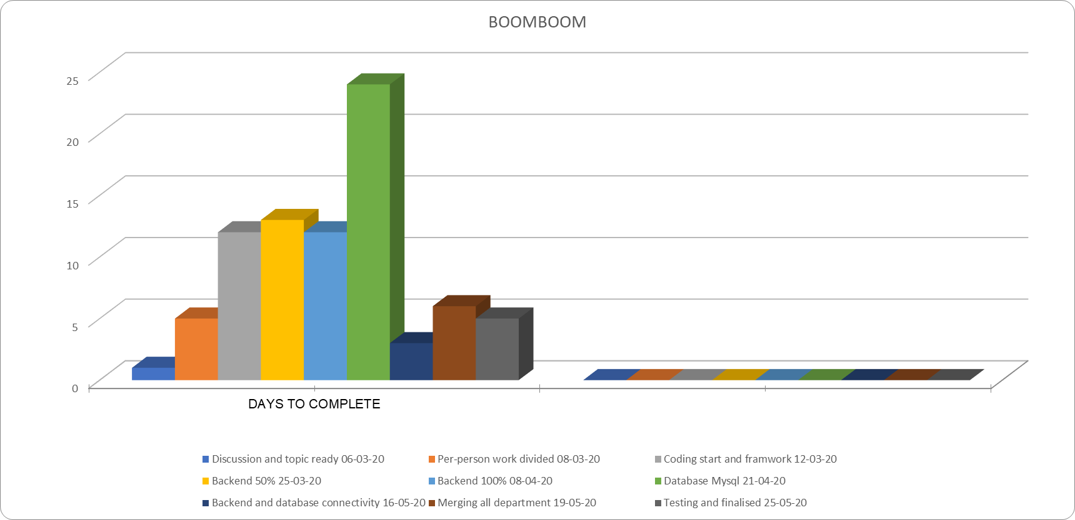

**INTRODUCTION**

This Project is Based On “MALL MANAGEMENT” Named As “BOOMBOOM MALL” , In This Project we are used basic Idea of City Mall , In which There are Five Floors along with Ground Floor , In Ground Floor there is an ‘Parking Lot’ , In First Floar There is an ‘Book Shop’ , In Second Floor There is an ‘Resturant’ , In Third Floor There is an ‘Cinema Hall’ & In Forth Floor There is an ‘Casino’.

**LANGUAGE WE ARE USED :**JAVA (java is pure object oriented language which supports lots of features such as Abstraction, Inheritance etc).

**DATABASE WE ARE USED :** MYSQL (mysql is an open source platform).

### PREQUISITE :

NetBeans Ver 6.9 and MySQL 5.1 or higher version must be installed on the PC to run the program.

### DATABASE INSTALLATION :

The software project is distributed with a backup copy of a Database named **boomboom** with required tables. Some dummy records are also present in the tables for testing purposes, which can be deleted before inserting real data. A sql script **boom.sql** is provided for this purpose.

To install database from **boom.sql**, simply follow the following procedure.

**Step 1:**

Reset the MySql password and make new root password (**12345**), if any other password is given by launching MySQL Server Instance config wizard **(Start⇨Programs⇨MySQL⇨MySQL server instance Config wizard** ).

Give current password and new password as “12345” for root.

**Step 2:**

Copy the **boom.sql** file in **C:\Program files\Mysql\MySql server 5.1\Bin** folder**.**

**Step 3:**

Load MySQL and create database named **School.**

**Mysql> create database boomboom;**

**Step 4:**

Go to the DOS prompt (Start⇨Run ⇨ type cmd and press enter) and go to the following folder using CD command of DOS.

**C:\.....> CD C:\Program files\Mysql\MySql server 5.1\Bin**

**Step 5:**

Type the following command on above DOS prompt.

**C:\….\bin>** mysql -u ***root*** –p***12345* boomboom** <boom.sql

This will create a library database with tables and records at target machine.

**Note:**

1. Don’t give space between –p and your password.

2. The boom.sql file must be present in Bin folder.

### How to run the Program :

To run the software open NetBeans and open the project (File ⇨ Open) and browse the **School** project from the location where the Library project folder exist. After loading the project choose Run command to run the program.

**TABLES (MySQL) USED IN PROJECT :-**

1. **Customer Table**

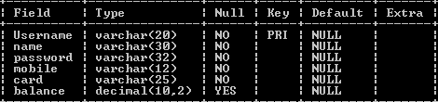

1. **Book Table :-**

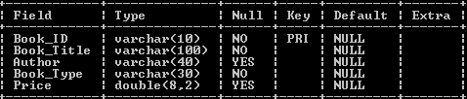

1. **Bookshop Table :-**

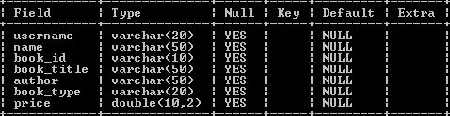

1. **Movie Table :-**

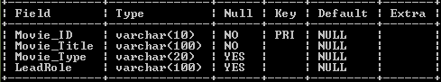

1. **Cinema Table :-**

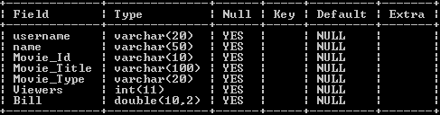

1. **Restaurant Table :-**

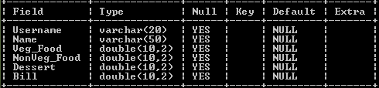

1. **Casino Table :-**

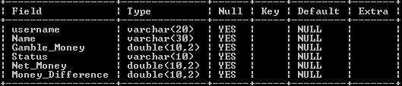

1. **Manager Table :-**

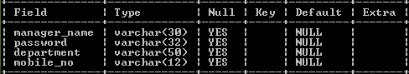

**JFRAMES (JAVA) USED IN PROJECT :-**

1. **Start.form**
2. **NewCustomerLetter.form**
3. **CustomerDetails.form**
4. **OldCustomer.form**
5. **Mall.form**
6. **Parking.form**
7. **Books_Shop.form**
8. **Book.form**
9. **Restaurant.form**
10. **Food.form**
11. **Cinema_Hall.form**
12. **Movie.form**
13. **Casino.form**
14. **Gamble.form**
15. **Customer_Department.form**
16. **Products_Department.form**
17. **Accounts_Department.form**

**Start JFrame**

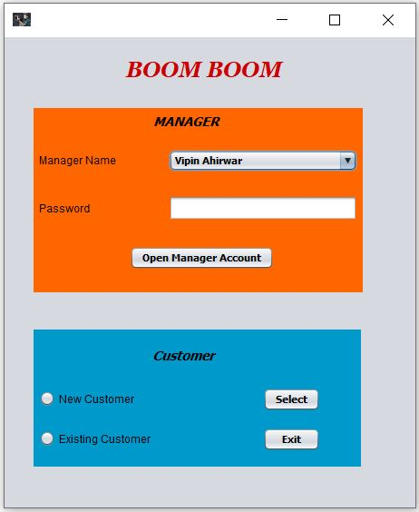

import javax.swing.ImageIcon;

import javax.swing.JFrame;

import javax.swing.JOptionPane;

public Start() {

initComponents();

this.setIconImage(new ImageIcon(getClass().getResource("/Images/afridi.jpg")).getImage()); }

private void btnexitActionPerformed(java.awt.event.ActionEvent evt) {

System.exit(0);

}

private void btnselectcustomerActionPerformed(java.awt.event.ActionEvent evt) {

if(radionewcustomer.isSelected())

{

new NewCustomerLetter().setVisible(true);

this.setVisible(false);

}

if(radiooldcustomer.isSelected())

{

new OldCustomer().setVisible(true);

this.setVisible(false);

}

}

private void btnmanageraccountActionPerformed(java.awt.event.ActionEvent evt) {

String password=managerpassword.getText();

switch(combomanager.getSelectedIndex())

{

case 0:

if(password.equals("vipin321"))

{

this.setVisible(false);

new Manager1().setVisible(true);

}

else

{

JOptionPane.showMessageDialog(this,"Invalid Password");

managerpassword.setText("");

}

break;

case 1:

if(password.equals("singh321"))

{

this.setVisible(false);

new Manager2().setVisible(true);

}

else

{

JOptionPane.showMessageDialog(this,"Invalid Password");

managerpassword.setText("");

}

break;

case 2:

if(password.equals("khuswaha321"))

{

this.setVisible(false);

new Manager3().setVisible(true);

}

else

{

JOptionPane.showMessageDialog(this,"Invalid Password");

managerpassword.setText("");

}

break;

case 3:

if(password.equals("dhankani321"))

{

this.setVisible(false);

new Manager4().setVisible(true);

}

else

{

JOptionPane.showMessageDialog(this,"Invalid Password");

managerpassword.setText("");

}

break;

case 4:

if(password.equals("sharma321"))

{

this.setVisible(false);

new Manager5().setVisible(true);

}

else

{

JOptionPane.showMessageDialog(this,"Invalid Password");

managerpassword.setText("");

}

break;

}

**NewCustomerLetter JFrame**

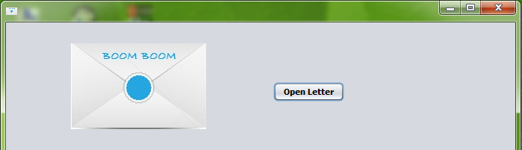

import javax.swing.ImageIcon;

public NewCustomerLetter() {

initComponents();

lblletter.setVisible(false);

btncheckoutmall.setVisible(false);

btnexit.setVisible(false);

this.setIconImage(new ImageIcon(getClass().getResource("/Images/close letter.jpg")).getImage());

private void btnopenletterActionPerformed(java.awt.event.ActionEvent evt) {

lblcloseletter.setIcon(new javax.swing.ImageIcon(getClass().getResource("/Images/open letter.jpg")));

lblletter.setVisible(true);

btncheckoutmall.setVisible(true);

btnexit.setVisible(true);

btnopenletter.setVisible(false);

}

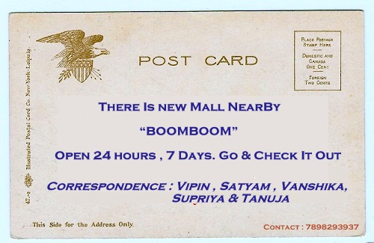

private void btncheckoutmallActionPerformed(java.awt.event.ActionEvent evt) {

new Custo merDetails().setVisible(true);

this.setVisible(false);

}

private void btnexitActionPerformed(java.awt.event.ActionEvent evt) {

System.exit(0);

}

**CustomerDetails JFrame**

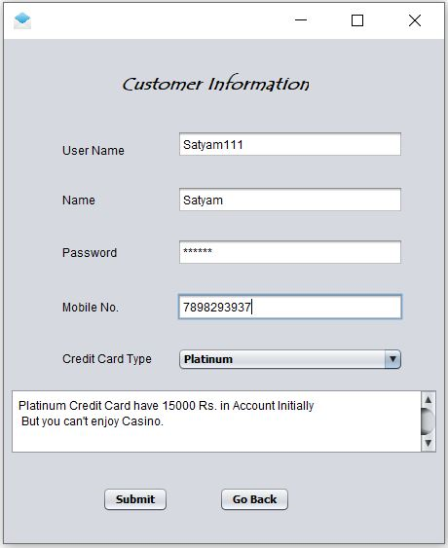

import java.sql.*;

import javax.swing.ImageIcon;

import javax.swing.JOptionPane;

public CustomerDetails() {

initComponents();

this.setIconImage(new ImageIcon(getClass().getResource("/Images/open letter.jpg")).getImage());

}

private void combocreditcardActionPerformed(java.awt.event.ActionEvent evt) {

switch(combocreditcard.getSelectedIndex())

{

case 0: tacreditcard.setText("Platinum Credit Card have 15000 Rs. in Account Initially"+"\n"+" But you can't enjoy Casino.");

break;

case 1: tacreditcard.setText("Gold Credit Card have 10000 Rs. in Account Initially"+"\n"+" But you can't enjoy Restaurant.");

break;

case 2: tacreditcard.setText("Silver Credit Card have 5000 Rs. in Account Initially"+"\n"+" And you can enjoy all 4 places.");

break;

} }

private void btnsubmitActionPerformed(java.awt.event.ActionEvent evt) {

try

{

Class.forName("com.mysql.jdbc.Driver");

Connection con =DriverManager.getConnection("jdbc:mysql://localhost:3306/boomboom","root","12345");

ResultSet rs=null;

Statement stmt=con.createStatement();

String username=tfusername.getText();

String name=tfname.getText();

String password=pfpassword.getText();

String mobile=tfmobile.getText();

String card=(String) combocreditcard.getSelectedItem();

Double balance = null;

switch(combocreditcard.getSelectedIndex())

{

case 0: balance=15000.00;

break;

case 1: balance=10000.00;

break;

case 2: balance=5000.00;

break;

default: JOptionPane.showMessageDialog(this,"Please Select Credit Card Type");

}

stmt.executeUpdate("Insert into customer values('"+(username)+"','"+(name)+"','"+(password)+"','"+(mobile)+"','"+(card)+"',"+(balance)+")");

JOptionPane.showMessageDialog(this," You have been added as a regular customer"+"\n"+"Now,you can enter the Boom Boom mall"+"\n"+"Click Go Back Button and Select Existing Customer.");

rs.close();

stmt.close();

con.close();

}

catch(Exception e)

{

JOptionPane.showMessageDialog(this,e.getMessage());

tfusername.setText("");

tfname.setText("");

pfpassword.setText("");

tfmobile.setText("");

}

}

private void btngobackActionPerformed(java.awt.event.ActionEvent evt) {

new Start().setVisible(true);

this.setVisible(false);

}

**CustomerDetails JFrame**

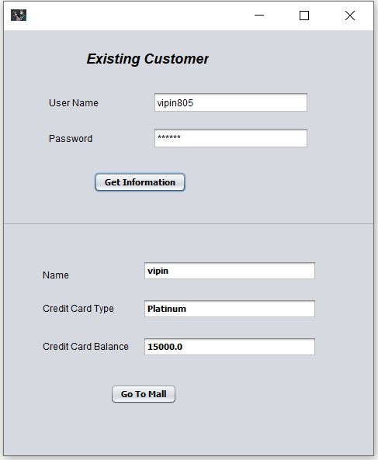

import java.sql.*;

import javax.swing.ImageIcon;

import javax.swing.JOptionPane;

public OldCustomer() {

initComponents();

panelinformation.setVisible(false);

this.setIconImage(new ImageIcon(getClass().getResource("/Images/afridi.jpg")).getImage());

}

private void btncustomerinformationActionPerformed(java.awt.event.ActionEvent evt) {

String username=tfusername.getText();

String password=pfpassword.getText();

String query = "SELECT * FROM customer WHERE Username = '" + (username) + "' && password='"+(password)+"'" ;

try {

Class.forName("com.mysql.jdbc.Driver");

Connection con = DriverManager.getConnection("jdbc:mysql://localhost:3306/boomboom","root","12345");

Statement stmt = con.createStatement();

ResultSet rs = stmt.executeQuery(query);

if (rs.next()) {

String name = rs.getString("name");

String card=rs.getString("card");

double balance=rs.getDouble("balance");

tfname.setText(""+name);

tfcard.setText(""+card);

tfbalance.setText(""+balance);

}

else

{

JOptionPane.showMessageDialog(null, "Invalid Username or Password");

tfusername.setText("");

pfpassword.setText("");

}

} catch (Exception e) {

JOptionPane.showMessageDialog(this, e.getMessage());

}

}

private void btngotomallActionPerformed(java.awt.event.ActionEvent evt) {

new Mall().setVisible(true);

this.setVisible(false);

}

**Mall JFrame**

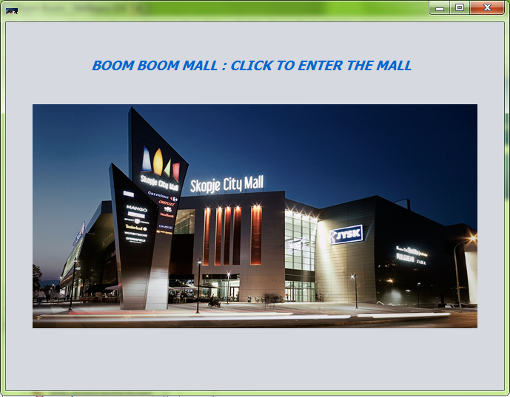

import javax.swing.ImageIcon;

public Mall() {

initComponents();

this.setIconImage(new ImageIcon(getClass().getResource("/Images/mall.jpg")).getImage());

}

private void btnmallActionPerformed(java.awt.event.ActionEvent evt) {

new Parking().setVisible(true);

this.setVisible(false);

}

**Parking JFrame**

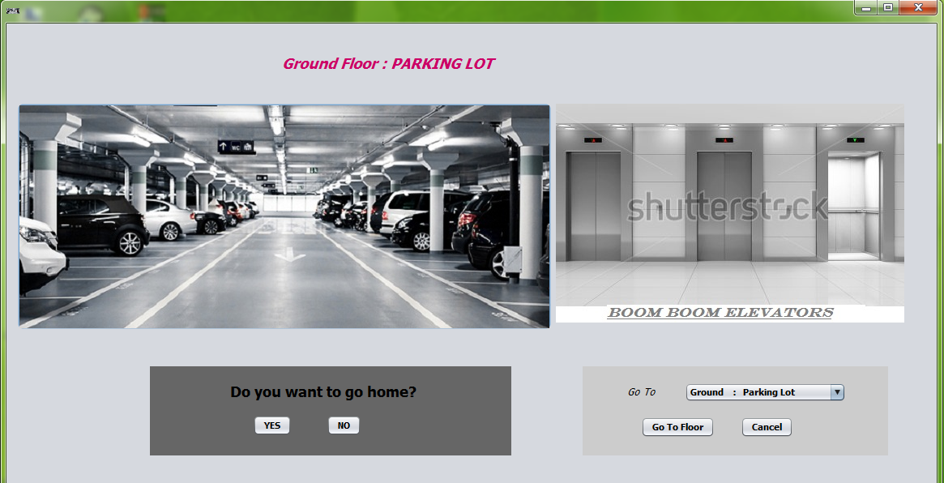

import javax.swing.ImageIcon;

import javax.swing.JOptionPane;

public Parking() {

initComponents();

panellift.setVisible(false);

panelparking.setVisible(false);

this.setIconImage(new ImageIcon(getClass().getResource("/Images/Parking.jpg")).getImage());

}

private void btnparkingActionPerformed(java.awt.event.ActionEvent evt) {

panelparking.setVisible(true);

}

private void btnparkingnoActionPerformed(java.awt.event.ActionEvent evt) {

panelparking.setVisible(false);

}

private void btnliftActionPerformed(java.awt.event.ActionEvent evt) {

panellift.setVisible(true);

}

private void btnliftgoActionPerformed(java.awt.event.ActionEvent evt) {

switch(combolift.getSelectedIndex())

{

case 0: this.setVisible(false);

new Parking().setVisible(true);

break;

case 1: this.setVisible(false);

new Books_Shop().setVisible(true);

break;

case 2: this.setVisible(false);

new Restaurant().setVisible(true);

break;

case 3: this.setVisible(false);

new Cinema_Hall().setVisible(true);

break;

case 4: this.setVisible(false);

new Casino().setVisible(true);

break;

}

}

private void btnliftcancelActionPerformed(java.awt.event.ActionEvent evt) {

panellift.setVisible(false);

}

private void btnparkingyesActionPerformed(java.awt.event.ActionEvent evt) {

JOptionPane.showMessageDialog(this,"Thank You for coming to Boom Boom Mall"+"\n"+"Come back Soon,We are waiting for you...");

new Start().setVisible(true);

this.setVisible(false);

}

**Books Shop JFrame**

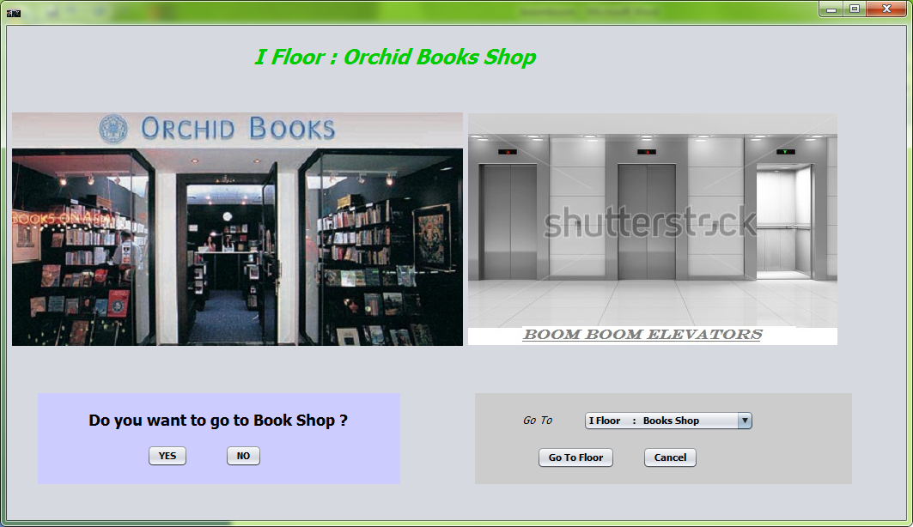

import javax.swing.ImageIcon;

public Books_Shop() {

initComponents();

panellift.setVisible(false);

panelbook.setVisible(false);

this.setIconImage(new ImageIcon(getClass().getResource("/Images/orchid_books_shop.jpg")).getImage());

}

private void btnliftActionPerformed(java.awt.event.ActionEvent evt) {

panellift.setVisible(true);

}

private void btnbooknoActionPerformed(java.awt.event.ActionEvent evt) {

panelbook.setVisible(false);

}

private void btnbookshopActionPerformed(java.awt.event.ActionEvent evt) {

panelbook.setVisible(true);

}

private void btnliftgoActionPerformed(java.awt.event.ActionEvent evt) {

switch(combolift.getSelectedIndex())

{

case 0: this.setVisible(false);

new Parking().setVisible(true);

break;

case 1: this.setVisible(false);

new Books_Shop().setVisible(true);

break;

case 2: this.setVisible(false);

new Restaurant().setVisible(true);

break;

case 3: this.setVisible(false);

new Cinema_Hall().setVisible(true);

break;

case 4: this.setVisible(false);

new Casino().setVisible(true);

break;

}

}

private void btnliftcancelActionPerformed(java.awt.event.ActionEvent evt) {

panellift.setVisible(false);

}

private void btnbookyesActionPerformed(java.awt.event.ActionEvent evt) {

this.setVisible(false);

new Book().setVisible(true);

}

**Book JFrame**

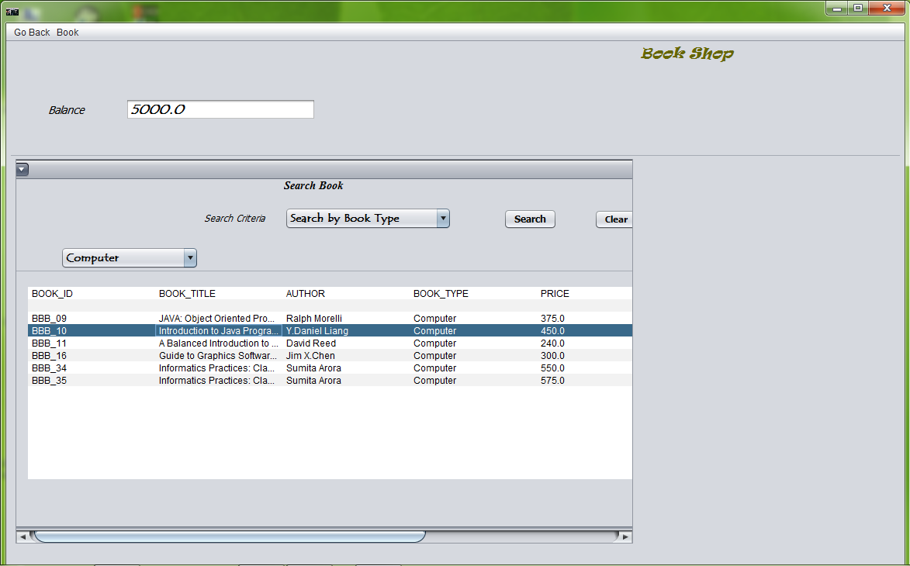

import java.sql.*;

import javax.swing.ImageIcon;

import javax.swing.JOptionPane;

import javax.swing.table.DefaultTableModel;

public Book() {

initComponents();

menubook.setEnabled(false);

lblbalance.setVisible(false);

tfbalance.setVisible(false);

panelprice.setVisible(false);

tfsearch.setVisible(false);

combobooktype.setVisible(false);

panelsearch.setVisible(false);

panelaboutbook.setVisible(false);

IFbookinventory.setVisible(false);

btnbuybook.setEnabled(false);

this.setIconImage(new ImageIcon(getClass().getResource("/Images/orchid_books_shop.jpg")).getImage());

}

private void btnsearchActionPerformed(java.awt.event.ActionEvent evt) {

DefaultTableModel model=(DefaultTableModel)tblsearch.getModel();

int rows=model.getRowCount();

if(rows>2)

{

for(int i=2;i<rows;i++)

{

model.removeRow(2);

}

}

try

{

Class.forName("com.mysql.jdbc.Driver");

Connection con = DriverManager.getConnection("jdbc:mysql://localhost:3306/boomboom","root","12345");

ResultSet rs = null;

Statement stmt = null;

String query;

String booksearch=tfsearch.getText();

switch(combosearchcriteria.getSelectedIndex())

{

case 0:

query = "SELECT * FROM book where Book_Title like'%"+(booksearch)+"%'";

stmt = con.createStatement();

rs = stmt.executeQuery(query);

while(rs.next())

{

model.addRow(new Object[]

{

rs.getString(1),rs.getString(2),rs.getString(3),rs.getString(4),rs.getDouble(5)});

}

System.out.println(rs.getString(1));

break;

case 1:

query = "SELECT * FROM book where Author like'%"+(booksearch)+"%'";

stmt = con.createStatement();

rs = stmt.executeQuery(query);

while(rs.next())

{

model.addRow(new Object[]

{

rs.getString(1),rs.getString(2),rs.getString(3),rs.getString(4),rs.getDouble(5)});

}

break;

case 2:

String booktype=(String) combobooktype.getSelectedItem();

query = "SELECT * FROM book where Book_Type='"+(booktype)+"'";

stmt = con.createStatement();

rs = stmt.executeQuery(query);

while(rs.next())

{

model.addRow(new Object[]

{

rs.getString(1),rs.getString(2),rs.getString(3),rs.getString(4),rs.getDouble(5)});

}

break;

case 3:

double minprice=Double.parseDouble(tfminprice.getText());

double maxprice=Double.parseDouble(tfmaxprice.getText());

query = "SELECT * FROM book where Price between'"+(minprice)+"'and'"+(maxprice)+"'";

stmt = con.createStatement();

rs = stmt.executeQuery(query);

while(rs.next())

{

model.addRow(new Object[]

{

rs.getString(1),rs.getString(2),rs.getString(3),rs.getString(4),rs.getDouble(5)});

}

break;

}

}

catch(Exception e)

{

JOptionPane.showMessageDialog(this,e.getMessage());

}

}

private void combosearchcriteriaActionPerformed(java.awt.event.ActionEvent evt) {

switch(combosearchcriteria.getSelectedIndex())

{

case 0: tfsearch.setVisible(true);

combobooktype.setVisible(false);

panelprice.setVisible(false);

break;

case 1: tfsearch.setVisible(true);

combobooktype.setVisible(false)

panelprice.setVisible(false);

break;

case 2: tfsearch.setVisible(false);

combobooktype.setVisible(true);

panelprice.setVisible(false);

break;

case 3: tfsearch.setVisible(false);

combobooktype.setVisible(false);

panelprice.setVisible(true);

break;

} }

private void menuexitbookshopActionPerformed(java.awt.event.ActionEvent evt) {

this.setVisible(false);

new Books_Shop().setVisible(true);

}

private void menusearchbookActionPerformed(java.awt.event.ActionEvent evt) {

IFbookinventory.setVisible(false);

panelaboutbook.setVisible(false);

panelsearch.setVisible(true);

}

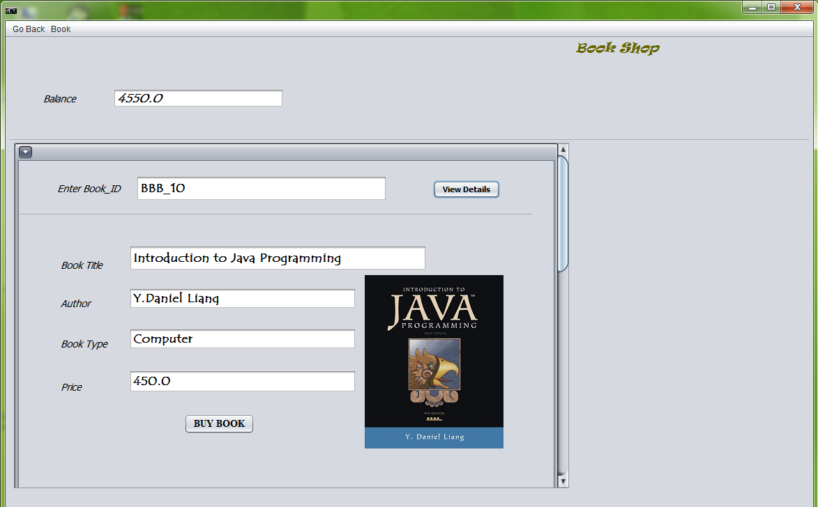

private void btnbuybookActionPerformed(java.awt.event.ActionEvent evt) {

Double balance=Double.parseDouble(tfbalance.getText());

String bookid=tfbookid.getText();

String booktitle=tfbooktitle.getText();

String author=tfauthor.getText();

String booktype=tfbooktype.getText();

Double price=Double.parseDouble(tfprice.getText());

try

{

String username=tfusername.getText();

Class.forName("com.mysql.jdbc.Driver");

Connection con = (Connection) DriverManager.getConnection("jdbc:mysql://localhost:3306/boomboom","root","12345");

ResultSet rs=null;

Statement stmt = con.createStatement();

String query1="Select * from customer where username='"+(username)+"'";

rs=stmt.executeQuery(query1);

if(rs.next())

{

if(balance>price)

{

String name=rs.getString("Name");

String query2="Insert into bookshop values('"+(username)+"','"+(name)+"','"+(bookid)+"','"+(booktitle)+"','"+(author)+"','"+(booktype)+"',"+(price)+") ";

stmt.executeUpdate(query2);

balance=balance-price;

tfbalance.setText(""+balance);

String query3="Update Customer set Balance="+(balance)+" where username='"+(username)+"'";

stmt.executeUpdate(query3);

JOptionPane.showMessageDialog(this,"You have succeesfully bought the book.");

}

else

{

JOptionPane.showMessageDialog(this,"You can't buy the book as price of book is more than your balance"+"\n"+"You can buy this book by selling other books at Half Price.");

}

}

}

catch(Exception e)

{

JOptionPane.showMessageDialog(this,"You can't buy the book."+"/n"+e.getMessage());

}

private void btnbookdetailsActionPerformed(java.awt.event.ActionEvent evt) {

String bookid=tfbookid.getText();

try

{

Class.forName("com.mysql.jdbc.Driver");

Connection con = DriverManager.getConnection("jdbc:mysql://localhost:3306/boomboom","root","12345");

String query = "SELECT * FROM book WHERE book_id = '"+(bookid)+"'" ;

Statement stmt = con.createStatement();

ResultSet rs = stmt.executeQuery(query);

if (rs.next()) {

Double price = rs.getDouble("price");

String booktitle=rs.getString("book_title");

String author=rs.getString("author");

String booktype=rs.getString("book_type");

tfprice.setText(""+price);

tfbooktitle.setText(""+booktitle);

tfauthor.setText(""+author);

tfbooktype.setText(""+booktype);

btnbuybook.setEnabled(true);

}

else

{

JOptionPane.showMessageDialog(this,"Invalid Book_ID");

}

}

catch(Exception e)

{

JOptionPane.showMessageDialog(this,e.getMessage());

}

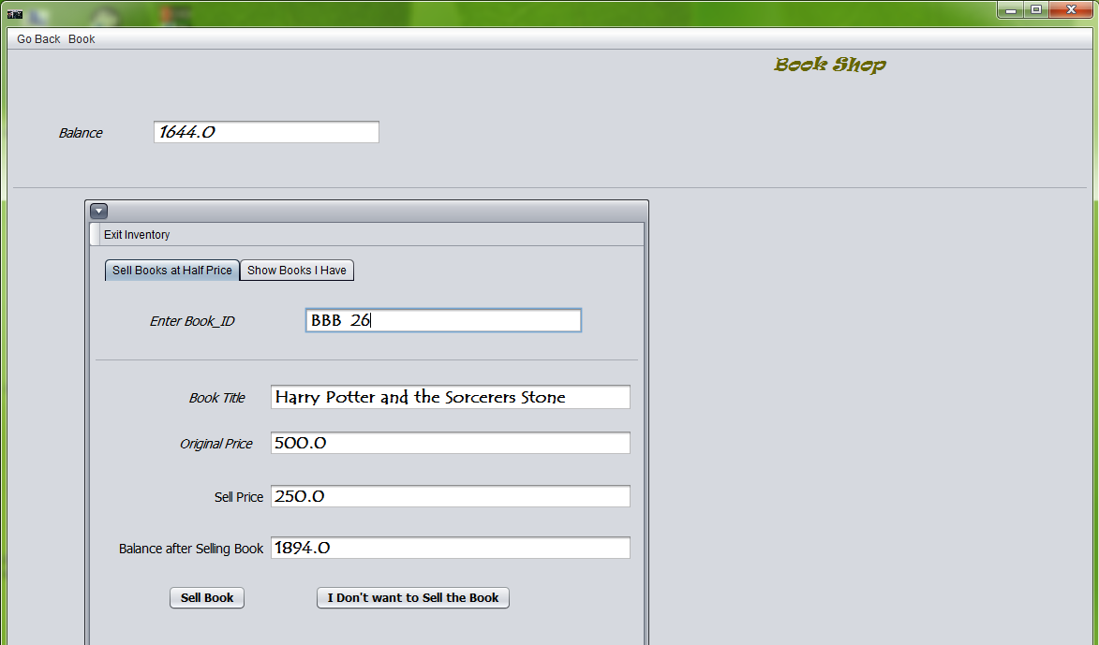

private void menuoldbookActionPerformed(java.awt.event.ActionEvent evt) {

panelaboutbook.setVisible(false);

panelsearch.setVisible(false);

IFbookinventory.setVisible(true);

IFbookinventory.setBounds(10, 150, 800,500);

String username=tfusername.getText();

DefaultTableModel model=(DefaultTableModel)tblbook.getModel();

int rows=model.getRowCount();

if(rows>1)

{ for(int i=1;i<rows;i++)

{

model.removeRow(1);

} }

try

{

Class.forName("com.mysql.jdbc.Driver");

Connection con = DriverManager.getConnection("jdbc:mysql://localhost:3306/boomboom","root","12345");

ResultSet rs = null;

Statement stmt = null;

String query;

query = "Select * from bookshop where username='"+(username)+"'";

stmt = con.createStatement();

rs = stmt.executeQuery(query);

while(rs.next())

{

model.addRow(new Object[]

{

rs.getString(3),rs.getString(4),rs.getDouble(7)});

} }

catch(Exception e)

{

JOptionPane.showMessageDialog(this,e.getMessage());

} }

private void btnexitinventoryActionPerformed(java.awt.event.ActionEvent evt) {

IFbookinventory.setVisible(false);

}

private void btnsellbookActionPerformed(java.awt.event.ActionEvent evt) {

String username=tfusername.getText();

String sellbookid=tfsellbookid.getText();

Double balance=Double.parseDouble(tfbalance.getText());

try{

Class.forName("com.mysql.jdbc.Driver");

Connection con = DriverManager.getConnection("jdbc:mysql://localhost:3306/boomboom","root","12345");

String query = "SELECT * FROM bookshop WHERE book_id = '"+(sellbookid)+"'and username='"+(username)+"'" ;

Statement stmt = con.createStatement();

ResultSet rs = stmt.executeQuery(query);

if (rs.next()) {

Double originalprice = rs.getDouble("price");

String sellbooktitle=rs.getString("book_title");

Double sellprice=originalprice/2;

balance=balance+sellprice;

tfselloriginalprice.setText(""+originalprice);

tfsellprice.setText(""+sellprice);

tfsellbalance.setText(""+balance);

tfbalance.setText(""+balance);

tfsellbooktitle.setText(""+sellbooktitle);

String query2="Delete from bookshop where username='"+(username)+"'and book_id='"+(sellbookid)+"'";

stmt.executeUpdate(query2);

String query3="Update Customer set Balance="+(balance)+" where username='"+(username)+"'";

stmt.executeUpdate(query3);

JOptionPane.showMessageDialog(this,"This book have been sold succeesfully");

tfsellbookid.setText("");

tfselloriginalprice.setText("");

tfsellprice.setText("");

tfsellbalance.setText("");

tfsellbooktitle.setText(""); }

else

{

JOptionPane.showMessageDialog(this,"You don't have the book with this Book_ID");

} }

catch(Exception e)

{

JOptionPane.showMessageDialog(this,e.getMessage());

} }

private void btndontsellbookActionPerformed(java.awt.event.ActionEvent evt) {

tfsellbookid.setText("");

tfselloriginalprice.setText("");

tfsellprice.setText("");

tfsellbalance.setText("");

tfsellbooktitle.setText(""); }

**Restaurant JFrame**

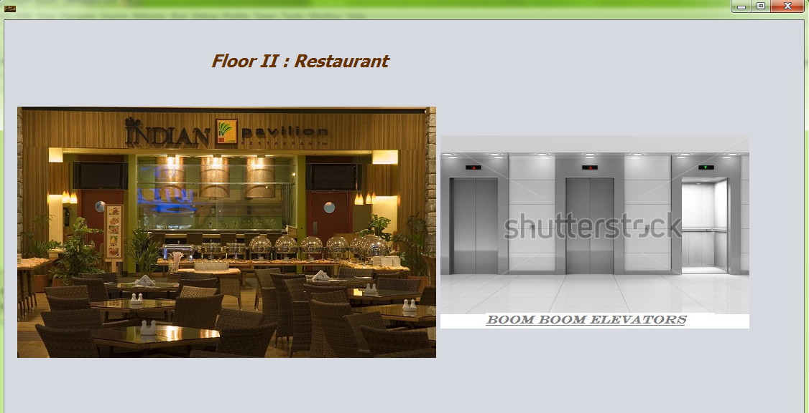

import javax.swing.ImageIcon;

public Restaurant() {

initComponents();

panellift.setVisible(false);

panelrestaurant.setVisible(false);

this.setIconImage(new ImageIcon(getClass().getResource("/Images/Indian-Pavillion.jpg")).getImage());

}

private void btnliftActionPerformed(java.awt.event.ActionEvent evt) {

panellift.setVisible(true);

}

private void btnrestaurantnoActionPerformed(java.awt.event.ActionEvent evt) {

panelrestaurant.setVisible(false);

}

private void jButton1ActionPerformed(java.awt.event.ActionEvent evt) {

panelrestaurant.setVisible(true);

}

private void btnliftgoActionPerformed(java.awt.event.ActionEvent evt) {

switch(combolift.getSelectedIndex())

{

case 0: this.setVisible(false);

new Parking().setVisible(true);

break;

case 1: this.setVisible(false);

new Books_Shop().setVisible(true);

break;

case 2: this.setVisible(false);

new Restaurant().setVisible(true);

break;

case 3: this.setVisible(false);

new Cinema_Hall().setVisible(true);

break;

case 4: this.setVisible(false);

new Casino().setVisible(true);

break;

}

}

private void btnliftcancelActionPerformed(java.awt.event.ActionEvent evt) {

panellift.setVisible(false);

}

private void btnrestaurantyesActionPerformed(java.awt.event.ActionEvent evt) {

this.setVisible(false);

new Food().setVisible(true);

}

**Food JFrame**

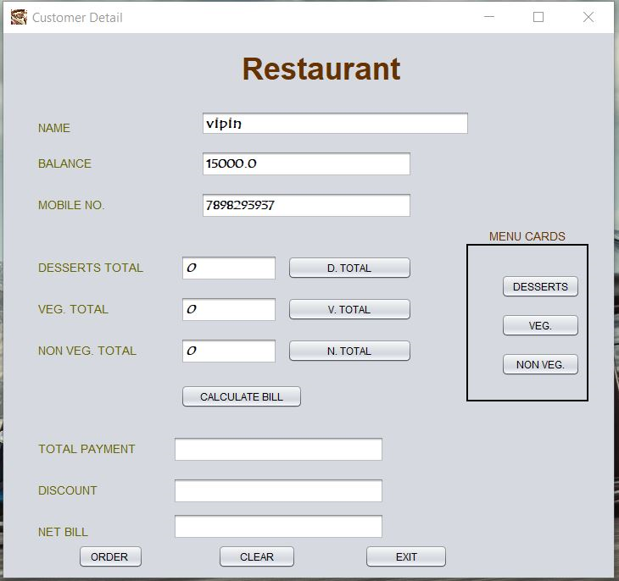

import javax.swing.JOptionPane;

import java.sql.*;

import javax.swing.ImageIcon;

public Food() {

initComponents();

tfdessert.setText("0");

tfveg.setText("0");

tfnonveg.setText("0");

}

private void jButton15ActionPerformed(java.awt.event.ActionEvent evt) {

this.setVisible(false);

Exit.setVisible(false);

new Restaurant().setVisible(true); }

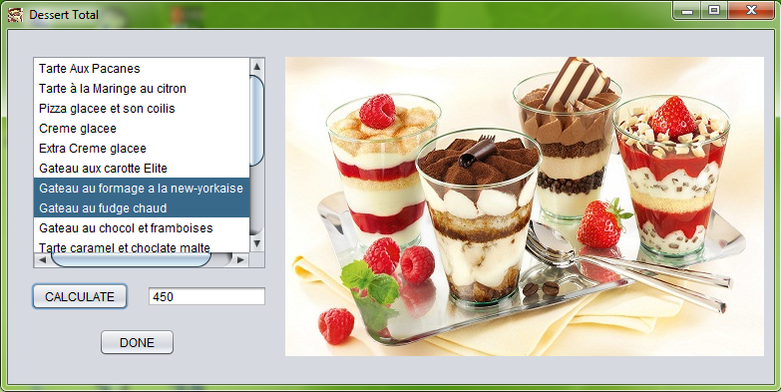

private void jButton13ActionPerformed(java.awt.event.ActionEvent evt) {

int sum=0,b;

String a;

if(list1.isSelectedIndex(0)==true)

{

a = JOptionPane.showInputDialog("No. Of Order Of Tarte Aux Pacanes");

b = Integer.parseInt(a);

sum = (sum + (195*b));

}

if(list1.isSelectedIndex(1)==true)

{

a = JOptionPane.showInputDialog("No. Of Order Of Tarte à la Maringe au citron");

b = Integer.parseInt(a);

sum = (sum + (195*b));

}

if(list1.isSelectedIndex(2)==true)

{

a = JOptionPane.showInputDialog("No. Of Order Of Pizza glacee et son coilis");

b = Integer.parseInt(a);

sum = (sum + (225*b));

}

if(list1.isSelectedIndex(3)==true)

{

a = JOptionPane.showInputDialog("No. Of Order Of Creme glacee");

b = Integer.parseInt(a);

sum = (sum + (225*b));

}

if(list1.isSelectedIndex(4)==true)

{

a = JOptionPane.showInputDialog("No. Of Order Of Extra Creme glacee");

b = Integer.parseInt(a);

sum = (sum + (75*b));

}

if(list1.isSelectedIndex(5)==true)

{

a = JOptionPane.showInputDialog("No. Of Order Of Gateau aux carotte Elite");

b = Integer.parseInt(a);

sum = (sum + (225*b));

}

if(list1.isSelectedIndex(6)==true)

{

a = JOptionPane.showInputDialog("No. Of Order Of Gateau aux carotte Elite");

b = Integer.parseInt(a);

sum = (sum + (225*b));

}

if(list1.isSelectedIndex(7)==true)

{

a = JOptionPane.showInputDialog("No. Of Order Of Gateau au fudge chaud");

b = Integer.parseInt(a);

sum = (sum + (225*b));

}

if(list1.isSelectedIndex(8)==true)

{

a = JOptionPane.showInputDialog("No. Of Order Of Gateau au chocol et framboises");

b = Integer.parseInt(a);

sum = (sum + (225*b));

}

a1.setText(""+sum);

}

private void jButton14ActionPerformed(java.awt.event.ActionEvent evt) {

int a;

DesL.setVisible(false);

a = Integer.parseInt(a1.getText());

tfdessert.setText(""+a);

} 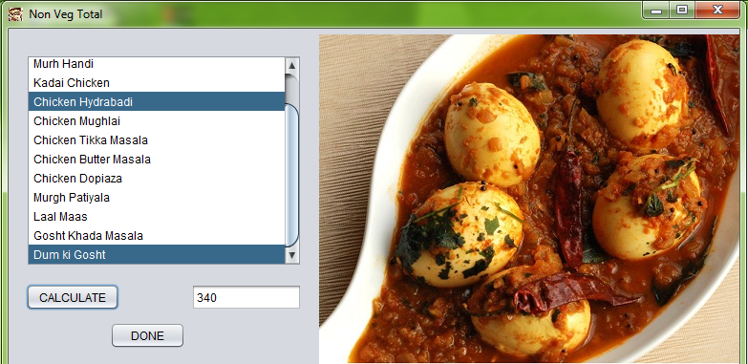

private void btnvegtotalActionPerformed(java.awt.event.ActionEvent evt) {

vegL.setVisible(true);

vegL.setSize(784, 393);

}

private void btnnonvegtotalActionPerformed(java.awt.event.ActionEvent evt) {

nvegL.setVisible(true);

nvegL.setSize(784, 393);

}

private void jButton16ActionPerformed(java.awt.event.ActionEvent evt) {

int sum=0,b;

String a;

if(list2.isSelectedIndex(0)==true)

{

a = JOptionPane.showInputDialog("No. Of Order Of Subz Handi");

b = Integer.parseInt(a);

sum = (sum + (110*b));

}

if(list2.isSelectedIndex(1)==true)

{

a = JOptionPane.showInputDialog("No. Of Order Of Dum ki Gobi");

b = Integer.parseInt(a);

sum = (sum + (110*b));

}

if(list2.isSelectedIndex(2)==true)

{

a = JOptionPane.showInputDialog("No. Of Order Of Corn Capsium");

b = Integer.parseInt(a);

sum = (sum + (110*b));

}

if(list2.isSelectedIndex(3)==true)

{

a = JOptionPane.showInputDialog("No. Of Order Of Lucknowi Kofta");

b = Integer.parseInt(a);

sum = (sum + (125*b));

}

if(list2.isSelectedIndex(4)==true)

{

a = JOptionPane.showInputDialog("No. Of Order Of Dingri mutter Harapyaz");

b = Integer.parseInt(a);

sum = (sum + (110*b));

}

a2.setText(""+sum);

}

private void jButton17ActionPerformed(java.awt.event.ActionEvent evt) {

int a;

vegL.setVisible(false);

a = Integer.parseInt(a2.getText());

tfveg.setText(""+a);

}

private void jButton18ActionPerformed(java.awt.event.ActionEvent evt) {

int sum=0,b;

String a;

if(list3.isSelectedIndex(0)==true)

{

a = JOptionPane.showInputDialog("No. Of Order Of Dhanya Murgh");

b = Integer.parseInt(a);

sum = (sum + (155*b));

}

if(list3.isSelectedIndex(1)==true)

{

a = JOptionPane.showInputDialog("No. Of Order Of Muragh Peshawari");

b = Integer.parseInt(a);

sum = (sum + (165*b));

}

if(list3.isSelectedIndex(2)==true)

{

a = JOptionPane.showInputDialog("No. Of Order Of Murh Handi");

b = Integer.parseInt(a);

sum = (sum + (155*b));

}

if(list3.isSelectedIndex(3)==true)

{

a = JOptionPane.showInputDialog("No. Of Order Of Kadai Chicken");

b = Integer.parseInt(a);

sum = (sum + (155*b));

}

a3.setText(""+sum);

}

private void jButton19ActionPerformed(java.awt.event.ActionEvent evt) {

int a;

nvegL.setVisible(false);

a = Integer.parseInt(a3.getText());

tfnonveg.setText(""+a);

}

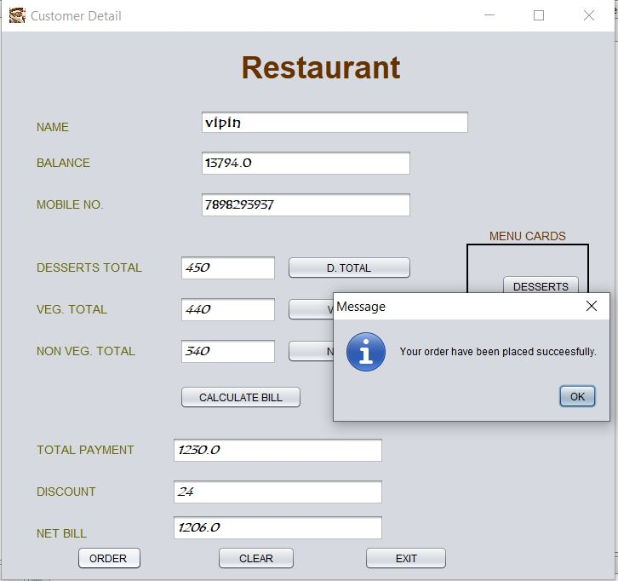

private void btnbillActionPerformed(java.awt.event.ActionEvent evt) {

double dessert,veg,nonveg,payment,bill;

int discount;

dessert = Double.parseDouble(tfdessert.getText());

veg = Double.parseDouble(tfveg.getText());

nonveg = Double.parseDouble(tfnonveg.getText());

payment = dessert+veg+nonveg;

tftotalpayment.setText(""+payment);

if(payment>=1000)

{

discount=(int) (payment*0.02);

}

else if(payment>=2000)

{

discount=(int) (payment*0.05);

}

else if(payment>=5000)

{

discount=(int) (payment*0.1);

}

else if(payment>=10000)

{

discount=(int) (payment*0.15);

}

else

{

discount=0;

}

tfdiscount.setText(""+discount);

bill=payment-discount;

tfnetbill.setText(""+bill);

}

private void btnorderActionPerformed(java.awt.event.ActionEvent evt) {

try

{

Class.forName("com.mysql.jdbc.Driver");

Connection con = DriverManager.getConnection("jdbc:mysql://Localhost:3306/boomboom","root","12345");

Statement stmt = con.createStatement();

Double balance=Double.parseDouble(tfbalance.getText());

String name = tfname.getText();

String username = tfusername2.getText();

Double dessert=Double.parseDouble(tfdessert.getText());

Double veg=Double.parseDouble(tfveg.getText());

Double nonveg=Double.parseDouble(tfnonveg.getText());

Double bill = Double.parseDouble(tfnetbill.getText());

if(balance>bill)

{

stmt.executeUpdate("insert into restaurant values('"+(username)+"','"+(name)+"',"+(veg)+","+(nonveg)+","+(dessert)+","+(bill)+")");

balance=balance-bill;

tfbalance.setText(""+balance);

String query3="Update Customer set Balance="+(balance)+" where username='"+(username)+"'";

stmt.executeUpdate(query3);

JOptionPane.showMessageDialog(null, "Your order have been placed succeesfully.");

}

else

{

JOptionPane.showMessageDialog(this,"You don't have enough balance to pay bill.");

}

tfdessert.setText("");

tfveg.setText("");

tfnonveg.setText("");

tfnetbill.setText("");

tftotalpayment.setText("");

tfdiscount.setText("");

}

catch(Exception e)

{

JOptionPane.showMessageDialog(null, e.getMessage()); } }

private void btnclearActionPerformed(java.awt.event.ActionEvent evt) {

tfnetbill.setText("");

tfdessert.setText("");

tfnonveg.setText("");

tfveg.setText("");

tftotalpayment.setText("");

tfdiscount.setText("");

}

**Cinema Hall JFrame**

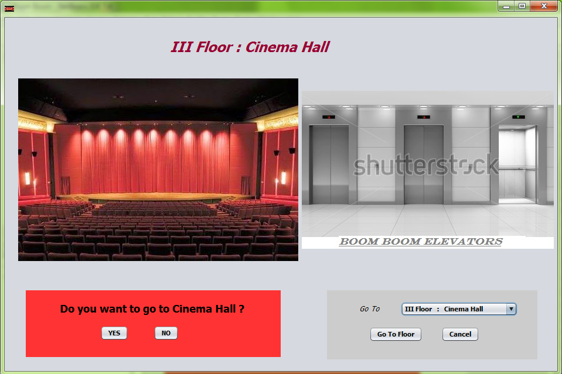

import javax.swing.ImageIcon;

public Cinema_Hall() {

initComponents();

panellift.setVisible(false);

panelcinema.setVisible(false);

this.setIconImage(new ImageIcon(getClass().getResource("/Images/A8.jpg")).getImage());

}

private void btnliftActionPerformed(java.awt.event.ActionEvent evt) {

panellift.setVisible(true);

}

private void btncinemanoActionPerformed(java.awt.event.ActionEvent evt) {

panelcinema.setVisible(false);

}

private void btncinemaActionPerformed(java.awt.event.ActionEvent evt) {

panelcinema.setVisible(true);

}

private void btnliftgoActionPerformed(java.awt.event.ActionEvent evt) {

switch(combolift.getSelectedIndex())

{

case 0: this.setVisible(false);

new Parking().setVisible(true);

break;

case 1: this.setVisible(false);

new Books_Shop().setVisible(true);

break;

case 2: this.setVisible(false);

new Restaurant().setVisible(true);

break;

case 3: this.setVisible(false);

new Cinema_Hall().setVisible(true);

break;

case 4: this.setVisible(false);

new Casino().setVisible(true);

break;

}

}

private void btnliftcancelActionPerformed(java.awt.event.ActionEvent evt) {

panellift.setVisible(false);

}

private void btncinemayesActionPerformed(java.awt.event.ActionEvent evt) {

this.setVisible(false);

new Movie().setVisible(true);

}

**Movie JFrame**

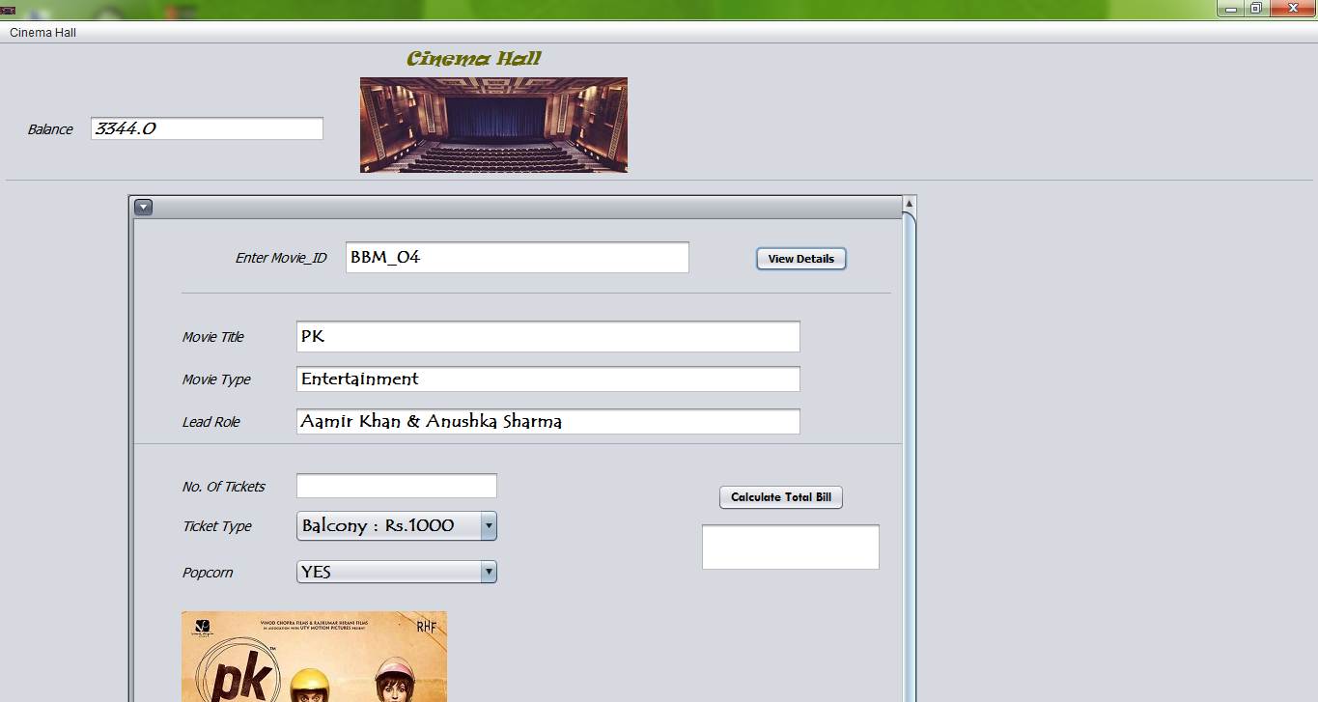

import java.sql.*;

import javax.swing.ImageIcon;

import javax.swing.JOptionPane;

import javax.swing.table.DefaultTableModel;

public Movie() {

initComponents();

menudetails.setEnabled(false);

menusearch.setEnabled(false);

lblbalance.setVisible(false);

tfbalance.setVisible(false);

tfsearch.setVisible(false);

combomovietype.setVisible(false);

panelsearch.setVisible(false);

panelaboutmovie.setVisible(false);

btntotalbill.setEnabled(false);

btnticketyes.setEnabled(false);

btnticketno.setEnabled(false);

this.setIconImage(new ImageIcon(getClass().getResource("/Images/pic9.jpg")).getImage());

}

private void btnmoviedetailsActionPerformed(java.awt.event.ActionEvent evt) {

String movieid=tfmovieid.getText();

try

{

Class.forName("com.mysql.jdbc.Driver");

Connection con = DriverManager.getConnection("jdbc:mysql://localhost:3306/boomboom","root","12345");

String query = "SELECT * FROM movie WHERE movie_id = '"+(movieid)+"'" ;

Statement stmt = con.createStatement();

ResultSet rs = stmt.executeQuery(query);

if (rs.next()) {

String movietitle=rs.getString("movie_title");

String leadrole=rs.getString("LeadRole");

String movietype=rs.getString("movie_type");

tfmovietitle.setText(""+movietitle);

tfmovietype.setText(""+movietype);

tfleadrole.setText(""+leadrole);

btntotalbill.setEnabled(true);

}

else

{

JOptionPane.showMessageDialog(this,"Invalid Movie_ID");

}

}

catch(Exception e)

{

JOptionPane.showMessageDialog(this,e.getMessage());

}

if(movieid.equals("BBM_01"))

{

lblmovieposter.setIcon(new javax.swing.ImageIcon(getClass().getResource("/Poster/BBM_01.jpg")));

}

else if(movieid.equals("BBM_02"))

{

lblmovieposter.setIcon(new javax.swing.ImageIcon(getClass().getResource("/Poster/BBM_02.jpg")));

}

else if(movieid.equals("BBM_03"))

{

lblmovieposter.setIcon(new javax.swing.ImageIcon(getClass().getResource("/Poster/BBM_03.jpg")));

}

else if(movieid.equals("BBM_04"))

{

lblmovieposter.setIcon(new javax.swing.ImageIcon(getClass().getResource("/Poster/BBM_04.jpg")));

}

else

{

lblmovieposter.setIcon(new javax.swing.ImageIcon(getClass().getResource("/Books/nopreview.png")));

}

}

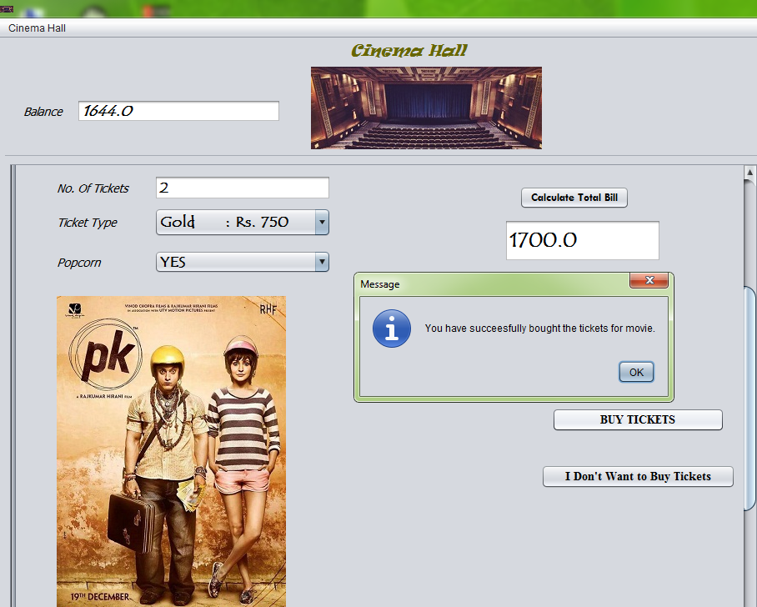

private void btnticketyesActionPerformed(java.awt.event.ActionEvent evt) {

Double balance=Double.parseDouble(tfbalance.getText());

String movieid=tfmovieid.getText();

String movietitle=tfmovietitle.getText();

String movietype=tfmovietype.getText();

String leadrole=tfleadrole.getText();

int viewer=Integer.parseInt(tfticketno.getText());

Double totalbill=Double.parseDouble(tftotalbill.getText());

try

{

String username=tfusername.getText();

Class.forName("com.mysql.jdbc.Driver");

Connection con = (Connection) DriverManager.getConnection("jdbc:mysql://localhost:3306/boomboom","root","12345");

ResultSet rs=null;

Statement stmt = con.createStatement();

String query1="Select * from customer where username='"+(username)+"'";

rs=stmt.executeQuery(query1);

if(rs.next())

{

if(balance>totalbill)

{

String name=rs.getString("Name");

String query2="Insert into cinema values('"+(username)+"','"+(name)+"','"+(movieid)+"','"+(movietitle)+"','"+(movietype)+"',"+(viewer)+","+(totalbill)+") ";

stmt.executeUpdate(query2);

balance=balance-totalbill;

tfbalance.setText(""+balance);

String query3="Update Customer set Balance="+(balance)+" where username='"+(username)+"'";

stmt.executeUpdate(query3);

JOptionPane.showMessageDialog(this,"You have succeesfully bought the tickets for movie.");

}

else

{

JOptionPane.showMessageDialog(this,"You can't buy the tickets for movie as price of tickets is more than your balance");

}

}

}

catch(Exception e)

{

JOptionPane.showMessageDialog(this,"You can't buy the tickets for movie."+"/n"+e.getMessage());

}

}

private void btnsearchActionPerformed(java.awt.event.ActionEvent evt) {

DefaultTableModel model=(DefaultTableModel)tblsearch.getModel();

int rows=model.getRowCount();

if(rows>2)

{

for(int i=2;i<rows;i++)

{

model.removeRow(2);

}

}

try

{

Class.forName("com.mysql.jdbc.Driver");

Connection con = DriverManager.getConnection("jdbc:mysql://localhost:3306/boomboom","root","12345");

ResultSet rs = null;

Statement stmt = null;

String query;

String moviesearch=tfsearch.getText();

switch(combosearchcriteria.getSelectedIndex())

{

case 0:

query = "SELECT * FROM movie where Movie_Title like'%"+(moviesearch)+"%'";

stmt = con.createStatement();

rs = stmt.executeQuery(query);

while(rs.next())

{

model.addRow(new Object[]

{

rs.getString(1),rs.getString(2),rs.getString(3),rs.getString(4)});

}

System.out.println(rs.getString(1));

break;

case 1:

query = "SELECT * FROM movie where LeadRole like'%"+(moviesearch)+"%'";

stmt = con.createStatement();

rs = stmt.executeQuery(query);

while(rs.next())

{

model.addRow(new Object[]

{

rs.getString(1),rs.getString(2),rs.getString(3),rs.getString(4)});

}

break;

case 2:

String movietype=(String) combomovietype.getSelectedItem();

query = "SELECT * FROM movie where movie_Type='"+(movietype)+"'";

stmt = con.createStatement();

rs = stmt.executeQuery(query);

while(rs.next())

{

model.addRow(new Object[]

{

rs.getString(1),rs.getString(2),rs.getString(3),rs.getString(4)});

}

break;

} }

catch(Exception e)

{

JOptionPane.showMessageDialog(this,e.getMessage());

} }

private void btntotalbillActionPerformed(java.awt.event.ActionEvent evt) {

int bill=0,ticket;

double totalbill;

switch(combotickettype.getSelectedIndex())

{

case 0:bill=1000;

break;

case 1:bill=750;

break;

case 2: bill=500;

break;

}

switch(combopopcorn.getSelectedIndex())

{

case 0:bill=bill+100;

break;

case 1: bill=bill+0;

}

ticket=Integer.parseInt(tfticketno.getText());

totalbill=ticket*bill;

tftotalbill.setText(""+totalbill); }

**Casino JFrame**

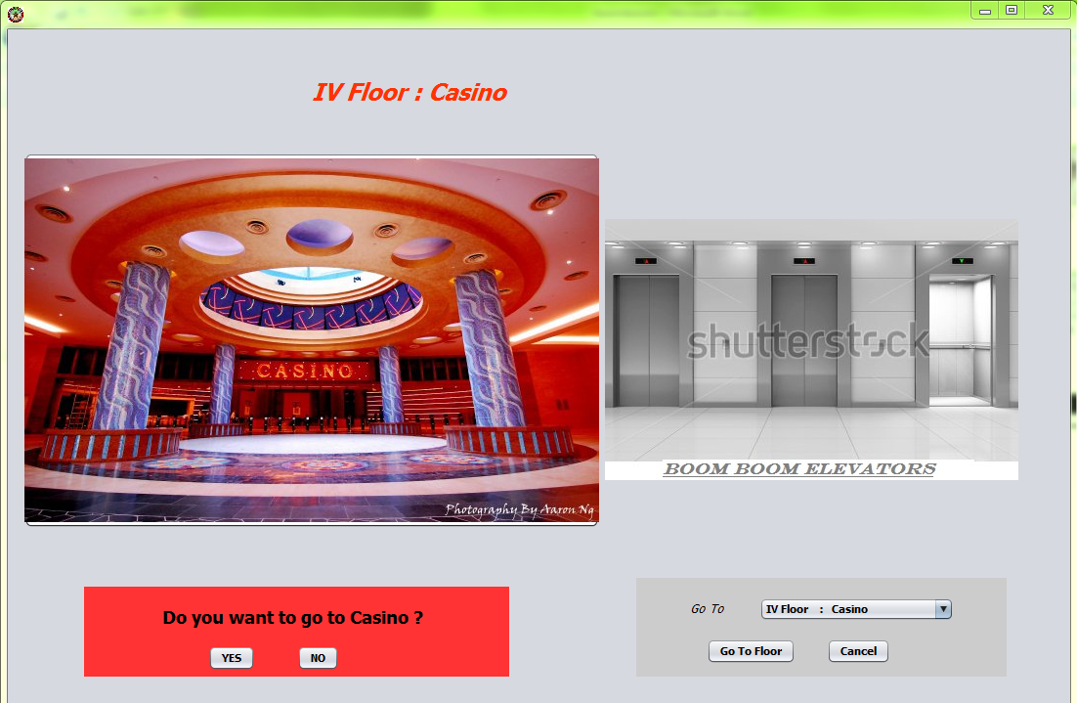

import javax.swing.ImageIcon;

public Casino() {

initComponents();

panellift.setVisible(false);

panelcasino.setVisible(false);

this.setIconImage(new ImageIcon(getClass().getResource("/Images/GamblersBarnstar-by-Everstar.png")).getImage());

}

private void btnliftActionPerformed(java.awt.event.ActionEvent evt) {

panellift.setVisible(true);

}

private void btncasinonoActionPerformed(java.awt.event.ActionEvent evt) {

panelcasino.setVisible(false);

}

private void btncasinoActionPerformed(java.awt.event.ActionEvent evt) {

panelcasino.setVisible(true);

}

private void btnliftgoActionPerformed(java.awt.event.ActionEvent evt) {

switch(combolift.getSelectedIndex())

{

case 0: this.setVisible(false);

new Parking().setVisible(true);

break;

case 1: this.setVisible(false);

new Books_Shop().setVisible(true);

break;

case 2: this.setVisible(false);

new Restaurant().setVisible(true);

break;

case 3: this.setVisible(false);

new Cinema_Hall().setVisible(true);

break;

case 4: this.setVisible(false);

new Casino().setVisible(true);

break;

}

}

private void btnliftcancelActionPerformed(java.awt.event.ActionEvent evt) {

panellift.setVisible(false);

}

private void btncasinoyesActionPerformed(java.awt.event.ActionEvent evt) {

this.setVisible(false);

new Gamble().setVisible(true);

}

**Gamble JFrame**

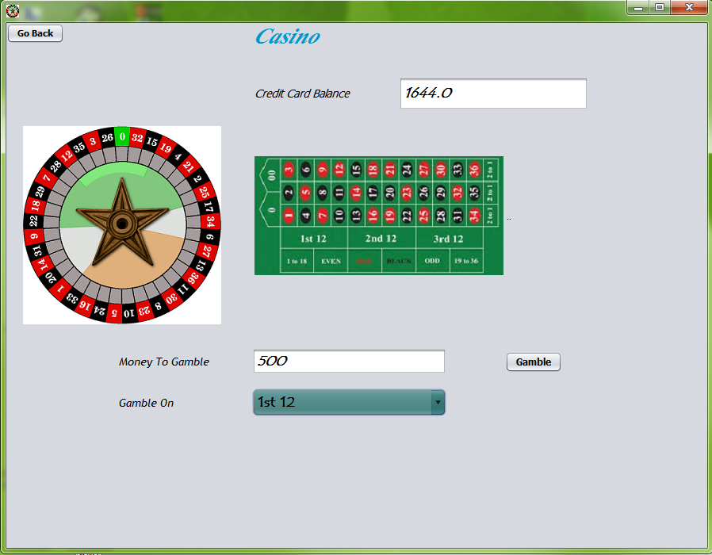

import java.sql.Connection;

import java.sql.DriverManager;

import java.sql.ResultSet;

import java.sql.Statement;

import javax.swing.ImageIcon;

import javax.swing.JOptionPane;

public Gamble() {

initComponents();

this.setSize(900,700);

paneloutput.setVisible(false);

panelgamble.setVisible(false);

lblbalance.setVisible(false);

tfbalance.setVisible(false);

lblroulette.setVisible(false);

lbltable.setVisible(false); }

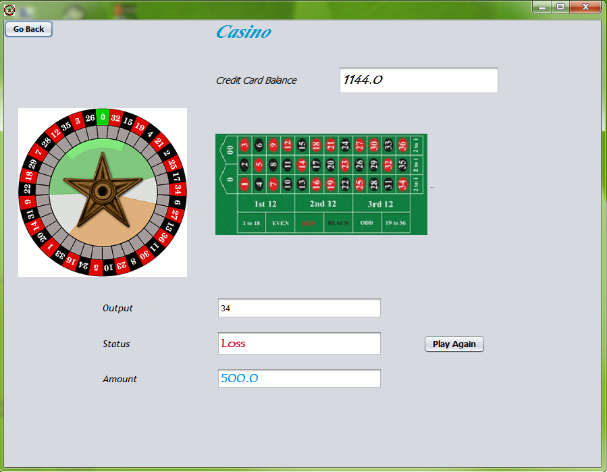

private void btngambleActionPerformed(java.awt.event.ActionEvent evt) {

double balance=Double.parseDouble(tfbalance.getText());

double money=Integer.parseInt(tfmoney.getText());

if(balance>money)

{

panelgamble.setVisible(false);

paneloutput.setVisible(true);

int output=((int)(Math.random()*36));

JOptionPane.showMessageDialog(this,output);

tfoutput.setText(""+output);

double net,amount = 0;

switch(combogamble.getSelectedIndex())

{

case 0: if(output>=1 && output<=12)

{

amount=money*3;

}

else

{

amount=0;

}

break;

case 1: if(output>=13 && output<=24)

{

amount=money*3;

}

else

{

amount=0;

}

break;

case 2: if(output>=25 && output<=36)

{

amount=money*3;

}

else

{

amount=0;

}

break;

case 3: if(output>=1 && output<=18)

{

amount=money*2;

}

else

{

amount=0;

}

break;

case 4: if(output>=19 && output<=36)

{

amount=money*2;

}

else

{

amount=0;

}

break;

case 5: if(output%2==1)

{

amount=money*2;

}

else

{

amount=0;

}

break;

case 6: if(output%2==0)

{

amount=money*2;

}

else

{

amount=0;

}

break;

else

{

amount=0;

}

break;

}

net=amount-money;

if(net>0)

{

tfstatus.setText("Profit");

tfamount.setText(""+net);

}

else if(net<0)

{

tfstatus.setText("Loss");

tfamount.setText(""+money);

}

else

{

tfstatus.setText("No Profit,No Loss");

tfamount.setText("0");

}

double total= (balance+net);

tfbalance.setText(""+total);

String status=tfstatus.getText();

try

{

String username=tfusername.getText();

String password=pfpassword.getText();

Class.forName("com.mysql.jdbc.Driver");

Connection con = (Connection) DriverManager.getConnection("jdbc:mysql://localhost:3306/boomboom","root","12345");

ResultSet rs=null;

Statement stmt = con.createStatement();

String query = "Update Customer Set balance="+(total)+" where username = '" +(username) + "' && password='"+(password)+"'" ;

stmt.executeUpdate(query);

String query1="Select * from customer where username='"+(username)+"'";

rs=stmt.executeQuery(query1);

if(rs.next())

{

String name=rs.getString("Name");

String query2="Insert into Casino values('"+(username)+"','"+(name)+"',"+(money)+",'"+(status)+"',"+(amount)+","+(net)+") ";

stmt.executeUpdate(query2);

}

}

catch(Exception e)

{

JOptionPane.showMessageDialog(this,e.getMessage());

}

}

else

{

JOptionPane.showMessageDialog(this,"The gambling money is more than your Credit Card balance"+"\n"+"You can sell some books at half price to earn money");

}

}

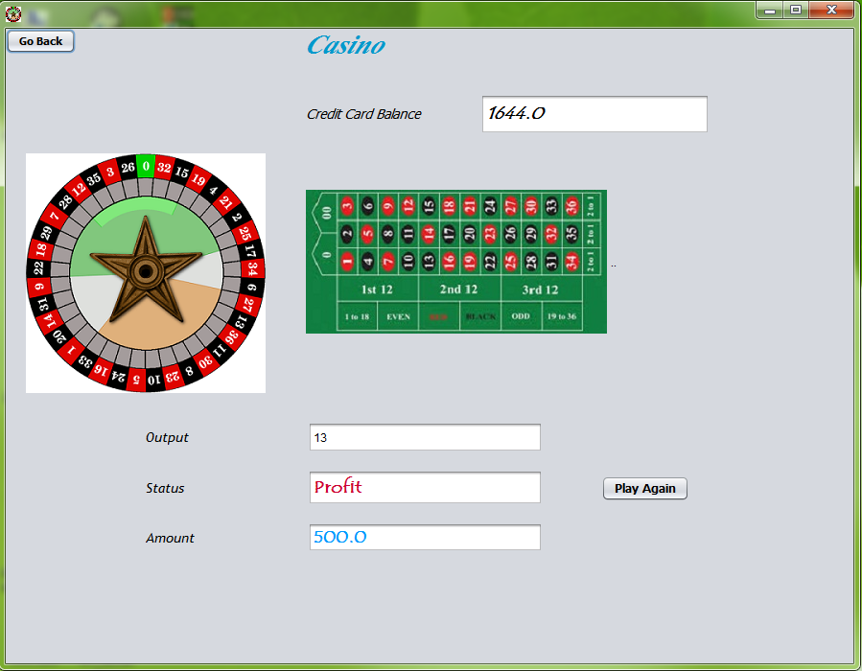

private void btnplayagainActionPerformed(java.awt.event.ActionEvent evt) {

panelgamble.setVisible(true);

paneloutput.setVisible(false);

tfoutput.setText("");

tfstatus.setText("");

tfamount.setText("");

}

private void btnsubmitActionPerformed(java.awt.event.ActionEvent evt) {

try

{

String username=tfusername.getText();

String password=pfpassword.getText();

Class.forName("com.mysql.jdbc.Driver");

Connection con = (Connection) DriverManager.getConnection("jdbc:mysql://localhost:3306/boomboom","root","12345");

String query = "SELECT * FROM Customer WHERE username = '" +(username) + "' && password='"+(password)+"'" ;

Statement stmt = con.createStatement();

ResultSet rs = stmt.executeQuery(query);

if(rs.next())

{

String card=rs.getString("card");

Double balance = rs.getDouble("balance");

if(card.equals("Platinum"))

{

JOptionPane.showMessageDialog(this,"Your Credit Card is Platinum type"+"\n"+"So,you can't enter the Casino");

this.setVisible(false);

new Casino().setVisible(true);

}

else

{

tfbalance.setText(""+balance);

panelgamble.setVisible(true);

lblbalance.setVisible(true);

tfbalance.setVisible(true);

lblroulette.setVisible(true);

lbltable.setVisible(true);

panellogin.setVisible(false);

}

}

else

{

JOptionPane.showMessageDialog(this,"Invalid Username or Password");

tfusername.setText("");

pfpassword.setText("");

}

}

catch(Exception e)

{

JOptionPane.showMessageDialog(this,e.getMessage());

}

}

private void btngobackActionPerformed(java.awt.event.ActionEvent evt) {

this.setVisible(false);

new Casino().setVisible(true);

}

**Customer Department JFrame**

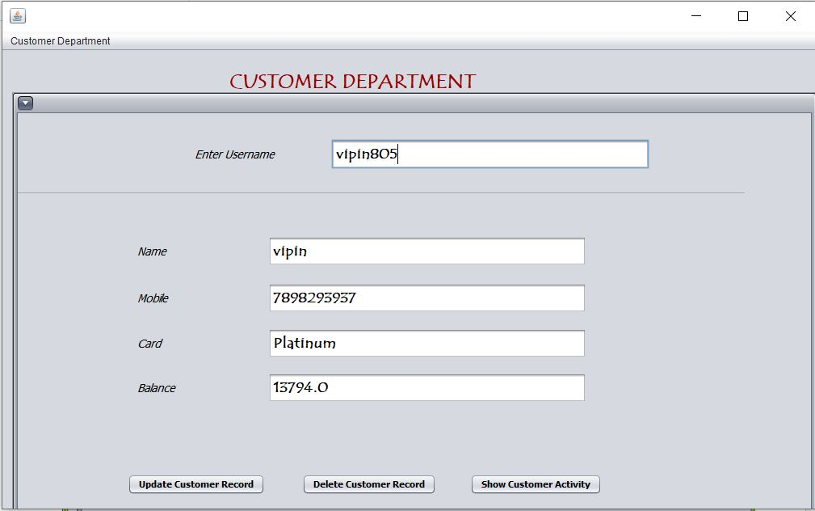

import java.sql.Connection;

import java.sql.DriverManager;

import java.sql.ResultSet;

import java.sql.Statement;

import javax.swing.ImageIcon;

import javax.swing.JOptionPane;

public Customer_Department() {

initComponents();

panelactivity.setVisible(false);

panelcustomer.setVisible(false);

private void btndeleteActionPerformed(java.awt.event.ActionEvent evt) {

String username=tfusername.getText();

try

{

Class.forName("com.mysql.jdbc.Driver");

Connection con = DriverManager.getConnection("jdbc:mysql://localhost:3306/boomboom","root","12345");

ResultSet rs = null;

Statement stmt = null;

String query="Delete from customer where username='"+(username)+"'";

stmt.executeUpdate(query);

JOptionPane.showMessageDialog(this,"Customer record deleted succeesfully.");

}

catch(Exception e)

{

JOptionPane.showMessageDialog(this,"Customer record can't be deleted"+"\n"+e.getMessage());

}

}

private void btnupdateActionPerformed(java.awt.event.ActionEvent evt) {

try

{

Class.forName("com.mysql.jdbc.Driver");

Connection con =DriverManager.getConnection("jdbc:mysql://localhost:3306/boomboom","root","12345");

ResultSet rs=null;

Statement stmt=con.createStatement();

String username=tfusername.getText();

String name=tfname.getText();

String balance=tfbalance.getText();

String mobile=tfmobile.getText();

String card=tfcard.getText();

String query1="Update customer set name='"+(name)+"' where username='"+(username)+"'";

String query2="Update customer set mobile='"+(mobile)+"' where username='"+(username)+"'";

String query3="Update customer set card='"+(card)+"' where username='"+(username)+"'";

String query4="Update customer set balance="+(balance)+" where username='"+(username)+"'";

stmt.executeUpdate(query1);

stmt.executeUpdate(query2);

stmt.executeUpdate(query3);

stmt.executeUpdate(query4);

JOptionPane.showMessageDialog(this,"Customer Record updated succeesfuly.");

}

catch(Exception e)

{

JOptionPane.showMessageDialog(this,e.getMessage());

}

}

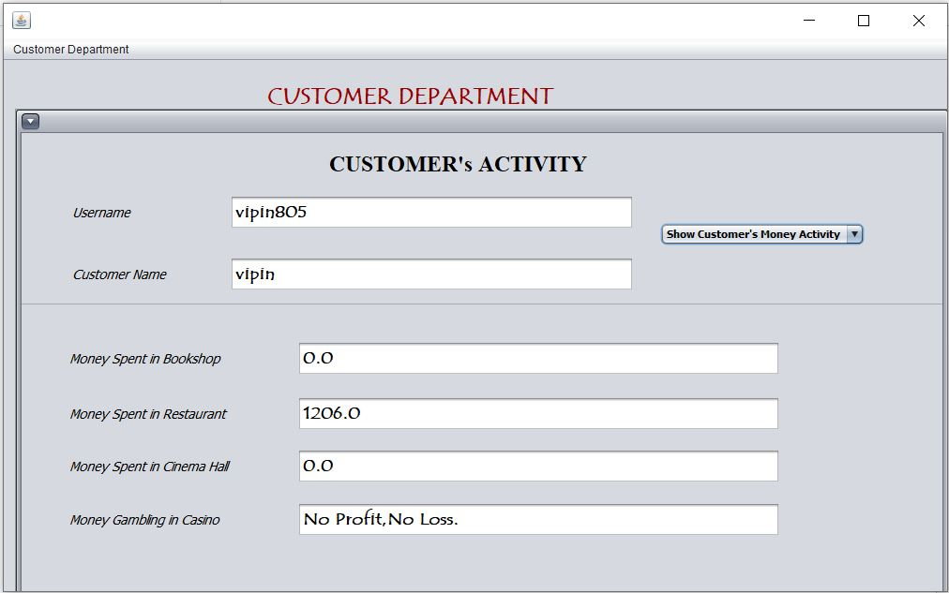

private void comboactivityActionPerformed(java.awt.event.ActionEvent evt) {

String username=tfusername.getText();

switch(comboactivity.getSelectedIndex())

{

case 0:

try

{

Class.forName("com.mysql.jdbc.Driver");

Connection con =DriverManager.getConnection("jdbc:mysql://localhost:3306/boomboom","root","12345");

ResultSet rs=null;

Statement stmt=con.createStatement();

String query1="Select * from bookshop where username='"+(username)+"'";

String query2="Select * from restaurant where username='"+(username)+"'";

String query3="Select * from cinema where username='"+(username)+"'";

String query4="Select * from casino where username='"+(username)+"'";

double bookshop=0,restaurant=0,cinema=0,casino=0;

ResultSet rs1=stmt.executeQuery(query1);

while(rs1.next())

{

Double price=rs1.getDouble("Price");

bookshop=bookshop+price;

}

tfbookshop.setText(""+bookshop);

jLabel10.setText("Money Spent in Bookshop");

ResultSet rs2=stmt.executeQuery(query2);

while(rs2.next())

{

Double bill=rs2.getDouble("Bill");

restaurant=restaurant+bill;

}

tfrestaurant.setText(""+restaurant);

jLabel12.setText("Money Spent in Restaurant");

ResultSet rs3=stmt.executeQuery(query3);

while(rs3.next())

{

Double bill=rs3.getDouble("Bill");

cinema=cinema+bill;

}

tfcinema.setText(""+cinema);

jLabel11.setText("Money Spent in Cinema Hall");

ResultSet rs4=stmt.executeQuery(query4);

while(rs4.next())

{

Double money=rs4.getDouble("Money_Difference");

casino=casino+money;

}

if(casino>0)

{

tfcasino.setText(" Profit : "+casino);

}

else if(casino<0)

{

tfcasino.setText(" Loss : "+(0-casino));

}

else

{

tfcasino.setText("No Profit,No Loss.");

}

jLabel13.setText("Money Gambling in Casino");

}

catch(Exception e)

{

JOptionPane.showMessageDialog(this,e.getMessage());

}

break; } }

private void menuexitdepartmentActionPerformed(java.awt.event.ActionEvent evt) {

this.setVisible(false);

new Manager1().setVisible(true);

}

**Products Department JFrame**

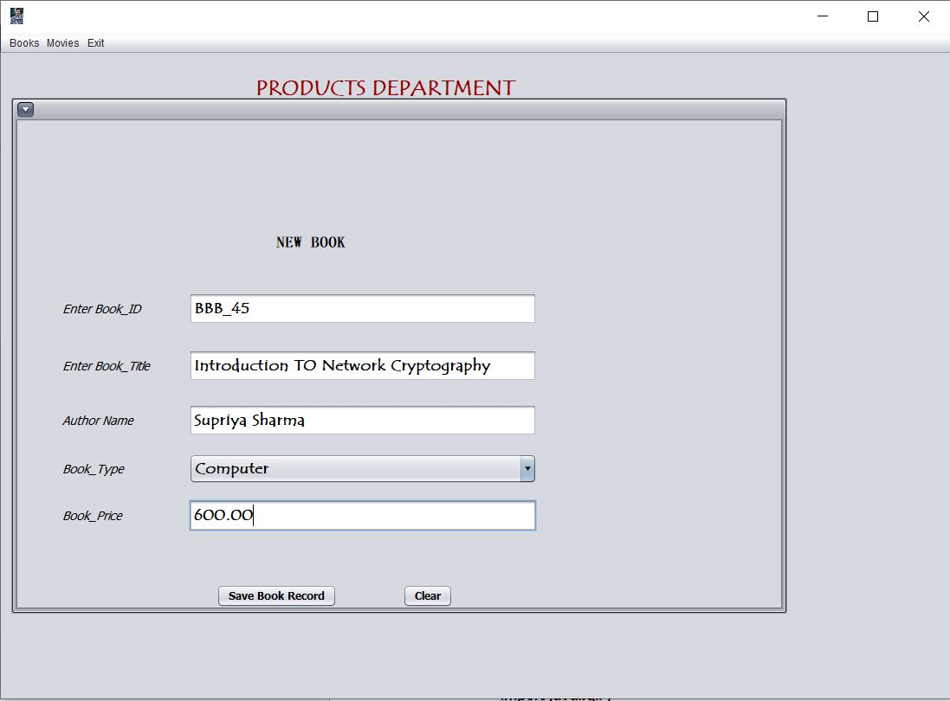

import java.sql.*;

import java.sql.Connection;

import java.sql.DriverManager;

import java.sql.ResultSet;

import java.sql.Statement;

import javax.swing.ImageIcon;

import javax.swing.JOptionPane;

import javax.swing.table.DefaultTableModel;

public Products_Department() {

initComponents();

panelnewbook.setVisible(false);

paneldeletebook.setVisible(false);

panelnewmovie.setVisible(false);

paneldeletemovie.setVisible(false);

panelprice.setVisible(false);

combomovietype.setVisible(false);

}

private void btnnewbooksaveActionPerformed(java.awt.event.ActionEvent evt) {

String bookid=tfnewbookid.getText();

String booktitle=tfnewbooktitle.getText();

String author=tfnewbookauthor.getText();

String booktype=(String) combonewbooktype.getSelectedItem();

Double price=Double.parseDouble(tfnewbookprice.getText());

try

{

Class.forName("com.mysql.jdbc.Driver");

Connection con = (Connection) DriverManager.getConnection("jdbc:mysql://localhost:3306/boomboom","root","12345");

ResultSet rs=null;

Statement stmt = con.createStatement();

String query="Insert into book values('"+(bookid)+"','"+(booktitle)+"','"+(author)+"','"+(booktype)+"',"+(price)+") ";

stmt.executeUpdate(query);

JOptionPane.showMessageDialog(this,"The Book record has been succeesfully saved.");

}

catch(Exception e)

{

JOptionPane.showMessageDialog(this,"The Book record can't be saved."+"\n"+e.getMessage());

}

tfnewbookid.setText("");

tfnewbooktitle.setText("");

tfnewbookauthor.setText("");

tfnewbookprice.setText("");

}

private void btnnewmoviesaveActionPerformed(java.awt.event.ActionEvent evt) {

String movieid=tfnewmovieid.getText();

String movietitle=tfnewmovietitle.getText();

String movietype=(String) combonewmovietype.getSelectedItem();

String leadrole=tfnewmovielead.getText();

try

{

Class.forName("com.mysql.jdbc.Driver");

Connection con = (Connection) DriverManager.getConnection("jdbc:mysql://localhost:3306/boomboom","root","12345");

ResultSet rs=null;

Statement stmt = con.createStatement();

String query="Insert into movie values('"+(movieid)+"','"+(movietitle)+"','"+(movietype)+"','"+(leadrole)+"') ";

stmt.executeUpdate(query);

JOptionPane.showMessageDialog(this,"The Movie record has been succeesfully saved.");

}

catch(Exception e)

{

JOptionPane.showMessageDialog(this,"The Movie record can't be saved."+"\n"+e.getMessage());

}

}

private void btndeletemovieActionPerformed(java.awt.event.ActionEvent evt) {

String movieid=tfdeletemovieid.getText();

try

{

Class.forName("com.mysql.jdbc.Driver");

Connection con = DriverManager.getConnection("jdbc:mysql://localhost:3306/boomboom","root","12345");

ResultSet rs = null;

Statement stmt = con.createStatement();

String query="Delete from movie where movie_id='"+(movieid)+"'";

stmt.executeUpdate(query);

JOptionPane.showMessageDialog(this,"Movie record deleted succeesfully.");

}

catch(Exception e)

{

JOptionPane.showMessageDialog(this,"Movie record can't be deleted"+"\n"+e.getMessage());

}

}

private void btndeletebookActionPerformed(java.awt.event.ActionEvent evt) {

String bookid=tfdeletebookid.getText();

try

{

Class.forName("com.mysql.jdbc.Driver");

Connection con = DriverManager.getConnection("jdbc:mysql://localhost:3306/boomboom","root","12345");

ResultSet rs = null;

Statement stmt = con.createStatement();

String query="Delete from book where book_id='"+(bookid)+"'";

stmt.executeUpdate(query);

JOptionPane.showMessageDialog(this,"Book record deleted succeesfully.");

}

catch(Exception e)

{

JOptionPane.showMessageDialog(this,"Book record can't be deleted"+"\n"+e.getMessage());

}

}

**Accounts Department JFrame**

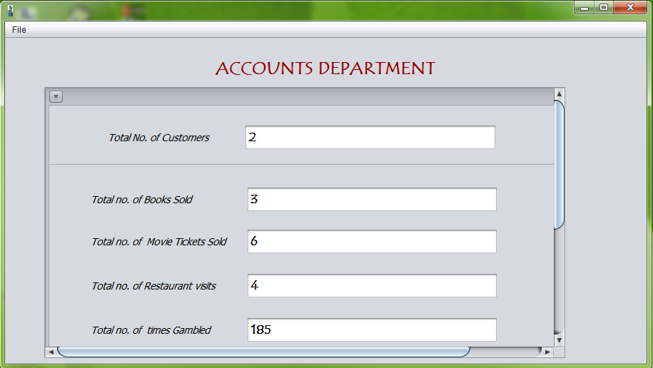

import java.sql.Connection;

import java.sql.DriverManager;

import java.sql.ResultSet;

import java.sql.Statement;

import javax.swing.ImageIcon;

import javax.swing.JOptionPane;

public Accounts_Department() {

initComponents();

paneldetails.setVisible(false);

this.setIconImage(new ImageIcon(getClass().getResource("/Manager/boomboom10.jpg")).getImage());

}

private void menudepartmentActionPerformed(java.awt.event.ActionEvent evt) {

paneldetails.setVisible(true);

try

{

Class.forName("com.mysql.jdbc.Driver");

Connection con = (Connection) DriverManager.getConnection("jdbc:mysql://localhost:3306/boomboom","root","12345");

Statement stmt = con.createStatement();

int customer=0,bookshop=0,restaurant=0,casino=0,cinema=0;

String query="Select * from customer";

String query1="Select * from bookshop";

String query2="Select * from cinema";

String query3="Select * from restaurant";

String query4="Select * from casino";

ResultSet rs=stmt.executeQuery(query);

while(rs.next())

{

customer++;

}

ResultSet rs1=stmt.executeQuery(query1);

while(rs1.next())

{

bookshop++;

}

ResultSet rs2=stmt.executeQuery(query2);

while(rs2.next())

{

int Viewers=rs2.getInt("Viewers");

cinema=cinema+Viewers;

}

ResultSet rs3=stmt.executeQuery(query3);

while(rs3.next())

{

restaurant++;

}

ResultSet rs4=stmt.executeQuery(query4);

while(rs4.next())

{

casino++;

}

tfcustomer.setText(""+customer);

tfcasino.setText(""+casino);

tfcinema.setText(""+cinema);

tfbookshop.setText(""+bookshop);

tfrestaurant.setText(""+restaurant);

}

catch(Exception e)

{

JOptionPane.showMessageDialog(this,e.getMessage());

}

}

private void menuexitActionPerformed(java.awt.event.ActionEvent evt) {

this.setVisible(false);

new Manager3().setVisible(true);

}